Performance analysis of hyperparameters of fully connected neural network
Machida Hiroaki
MET CS566 A1 Analysis of Algorithms (2020 Spring)

Table of Contents
Abstract 3
Introduction 3
Approach 4
Implementation 5
Prototype Source Code 5
Performance Evaluation 6
Accuracy 6
Time 6
Memory 7
Conclusion 7
Glossary 8
References and Links 8
Source code 9

Abstract
This project examines how the hyperparameter (number of hidden layers and number of neurons per layer) of fully connected neural network changes the accuracy.
The fully connected neural network uses the MNIST database of handwritten digit as training and test data.
The experiment showed that the higher number of neurons on each layer the model has, the more accurate the model is. On the other hand, it is counterintuitive, but the higher numbers of hidden layers resulted in worse accuracy.
Further investigation required, but, if there are too many hidden layers on training, the tail layer for higher-level features may discard information for lower-level features, and training falls into a local optimal solution.

Introduction
Fully connected neural network consists of a series of fully connected layers.
Figure 1. Architecture of fully connected neural network
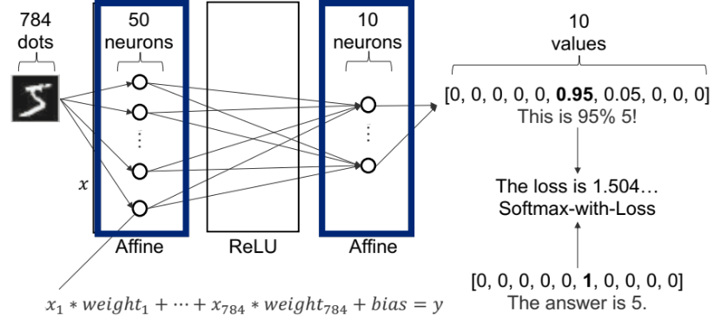
MNIST has 70,000 handwritten images in 28x28 pixels in gray level between 0 and 255 with labels.
Figure 2. MNIST database of handwritten digit
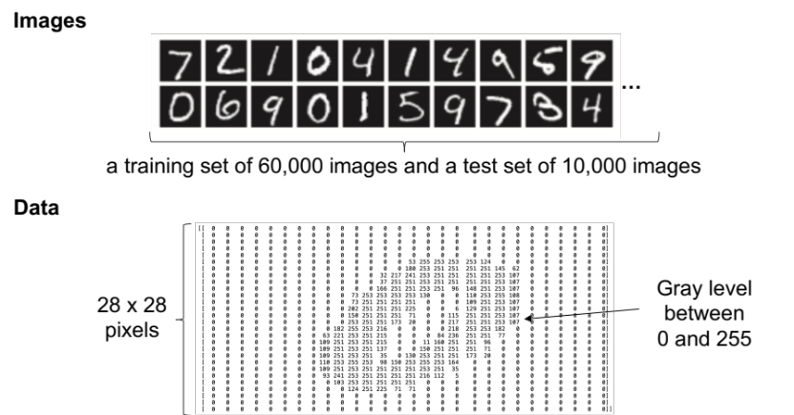

Approach
I conduct 50,000 iterations for each combination of number of neurons and number of hidden layers.
Figure 3. Approach
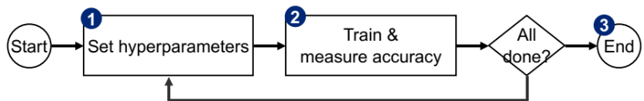
- Set hyperparameters with the combination of number of layers = [1,2,3,4,5] and number of neurons per layer = [1,2,4,8,16,32,64,128,256,512,1024,2048].
- Train with 50,000 iterations with the training set and measure accuracy(, time and memory) with the test set.
- In the end, get matrices of x:# of neurons on each layer and y:# of layers.
Figure 4. Output image
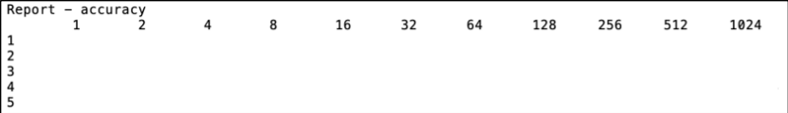

Implementation
The program is made based on a reference implementation of fully connected neural network.^{[1]} The structure of this project is as follows.
https://github.com/HiroakiMachida/metcs673-team1
./common:
layers.py Multiple layers for neural net

./dataset:
mnist.py MNIST data download

./main:
network.py Network construction
train.py Training execution
measure.py Measure combination of layers and neurons
train_experiment.py Experiment that shows training accuracy to see if there's over-fitting

Prototype Source Code
train.py
#!/usr/bin/env python3
# -*- coding: utf-8 -*-

import sys, os
sys.path.append(os.pardir)
from dataset.mnist import load_mnist
from network import Network

def train(hidden_size = 50, layer_size = 1):
# Load data (used the reference implementation)
try:
(x_train, t_train), (x_test, t_test) = load_mnist(normalize=True, one_hot_label=True)
except:
#print("Connect the internet.")
sys.exit()
# Initialize the two-layered network
network = Network(hidden_size=hidden_size, layer_size=layer_size)
iters_num = 50000 # Max limit of numpy is 60000
learning_rate = 0.1
test_acc_list = []
i_list = []
iter_per_epoch = 1000

iteration = tuple(range(iters_num))
for i in iteration:
# Calculate gradients.
grad = network.gradient(x_train[i], t_train[i])
# Update parameters.
for key in network.params:
network.params[key] -= learning_rate * grad[key]
if i % iter_per_epoch == 0:
i_list.append(i)
train_acc = network.accuracy(x_train, t_train)
test_acc = network.accuracy(x_test, t_test)
test_acc_list.append(test_acc)

return max(test_acc_list)

Performance Evaluation

Accuracy
The higher number of hidden layers, the worse accuracy.
Figure 5. Accuracy
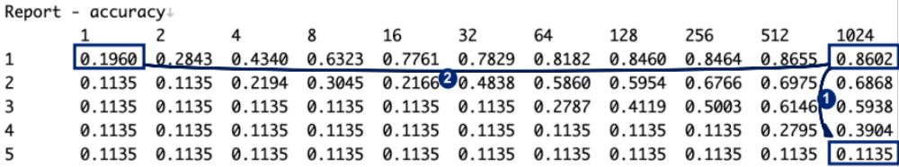
- The higher number of hidden layers the model has, the worse accuracy gets.
- The higher number of neurons each layer has, the better accuracy gets.

Time
Time increases linearly on the big neural networks.
Figure 6. Time
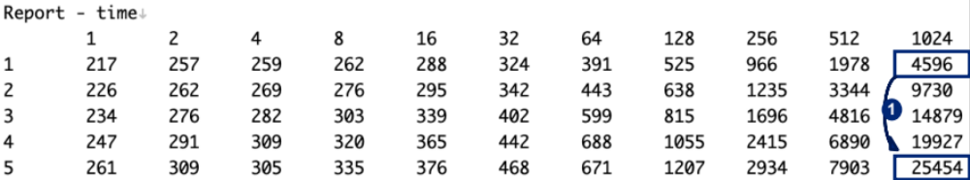
- The time to train gets longer linearly as the neural network gets bigger.

Memory
The size of neural network hardly effects the size of memory.
Figure 7. Memory
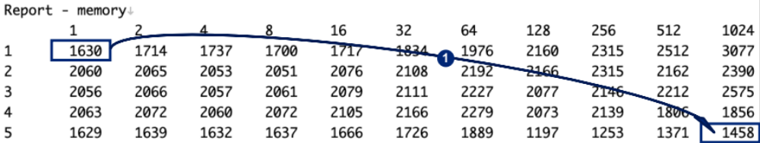
- The size of neural network hardly effects memory. Rather, memory decreased as the neural network gets bigger for some reason.

Conclusion
Why number of neurons per layer is more important than number of layers?: As intuition, accuracy gets better as the number of neurons on each layer increases. In contradiction to that, accuracy of fully connected neural network gets worse as the number of hidden layers increases. Ian Goodfellow^{[2]} points out that increasing the number of hidden layers much more than the sufficient number of layers will cause accuracy in the test set to decrease because of overfitting. However, an experiment in hand showed that even the maximum training accuracy of 2 layers with 1024 neurons per layer is as low as 0.70723, that is lower than 0.8602 of the test accuracy of 1 layer with 1024 neurons per layer. Hence, this is not the matter of overfitting. Further investigation required, but the hypothesis is that the 2nd hidden layer for higher-level features discards information for lower-level features that is important for such small images (28x28 pixels), and training falls into a local optimal solution.
What is optimum ratio number of neurons per layer to number of layers?: In the MNIST case, the higher number of neurons per layer, the better accuracy, without considering training time. What number of hidden layers is the best is yet to be investigated. One suggestion is to use genetic algorithm to identify what number of neurons per layer and number of hidden layers is the best. For example, assume the accuracy of 1 layer with 64 neurons per layer is already calculated, next calculate the accuracies of 1 layer with 128 and 2 layers with 64. If 1 layer with 128 is better, then calculate 1 layer with 256 and 2 layers with 128. Then, keep this process until the accuracy doesn’t get improved.
Memory: Memory is hardly effected by the size of neural network. That might be because the initial memory of python process is so huge (around 1.6GB) that it can be ignored.
Time: Time increases linearly on the big neural networks.

Glossary
N/A

References and Links
[1] Deep learning from scratch
https://github.com/oreilly-japan/deep-learning-from-scratch
[2] Josh Triplett, Paul E. McKenney, Jonathan Walpole. Resizable, Scalable, Concurrent Hash Tables. https://www.pdx.edu/sites/www.pdx.edu.computer-science/files/tr1101.pdf

Source code
https://github.com/HiroakiMachida/metcs673-team1

